CMPS 350 Fundamentals of Web Application Development Spring 2022

**Assignment 5**

|  |  |
| --- | --- |
| **Student Name** | Saeid Houti |
| **Student Id** | 201807500 |
| **Email** | Sh1807500@qu.edu.qa |

**Grading Rubric - - In the *Functionality* column please specify either: *Working (completed x%)*, *Not Working (completed x%)* or *Not done*.**

|  |  |  |  |  |
| --- | --- | --- | --- | --- |
| Criteria | % | Functionality | Quality of the implementation | Score |
| 1. Created employee and department models with all the necessary validations and relationship | 20 | 20% |  |  |
| 1. Created the following methods in the repository    1. Add Employee    2. Get Single Employee    3. Get All Employees    4. Update Employee    5. Delete Employee    6. Delete All Employees    7. Add Department    8. Get Single Department    9. Get All Departments | 65 | 65% |  |  |
| 1. Created the following two aggregation methods    1. Get Department Statistics (used aggregation)    2. Get Departments with their Employees | 15 | 15% |  |  |
| Total | 100 | 100% |  |  |
| Copying and/or plagiarism or not being able to explain or answer questions about the implementation | -100 |  |  |  |

**Possible grading for functionality**:

* ***Complete and Working*** (get 70% of the assigned grade),
* ***Complete and Not working*** (lose 40% of assigned grade)
* ***Not done*** get 0.
* The remaining grade is assigned to the quality of the implementation.
* Must submit screenshots in this **Testing-GradingSheet.docx** (otherwise - 10pts).

## Testing evidence (You should provide a screenshot of your work)

Getting

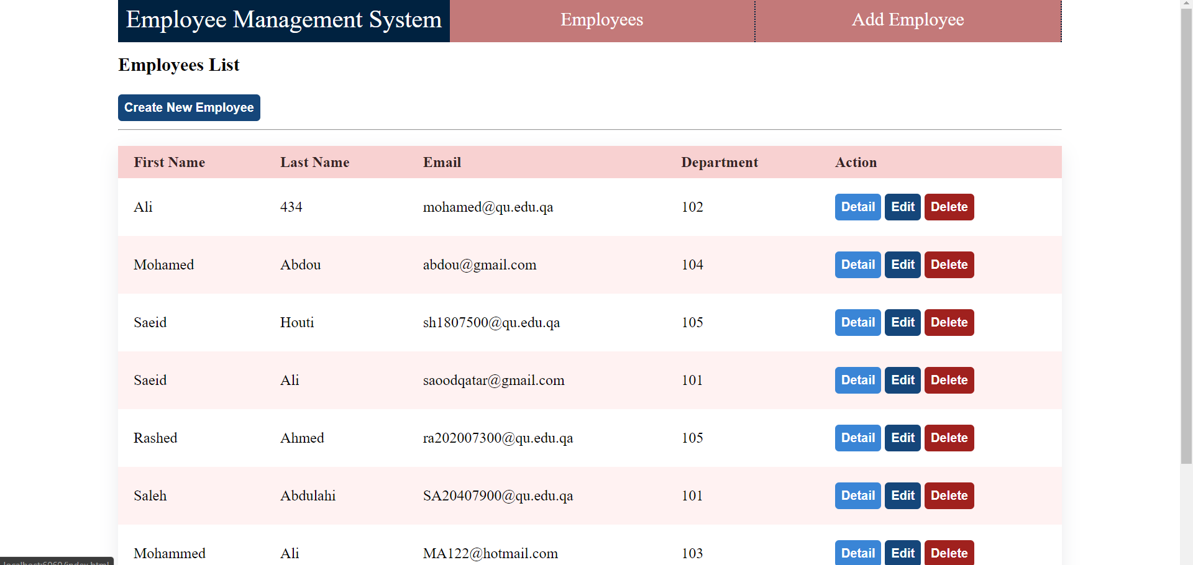

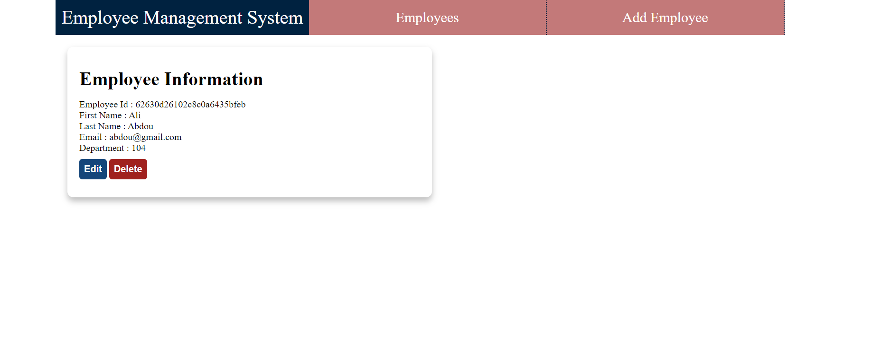

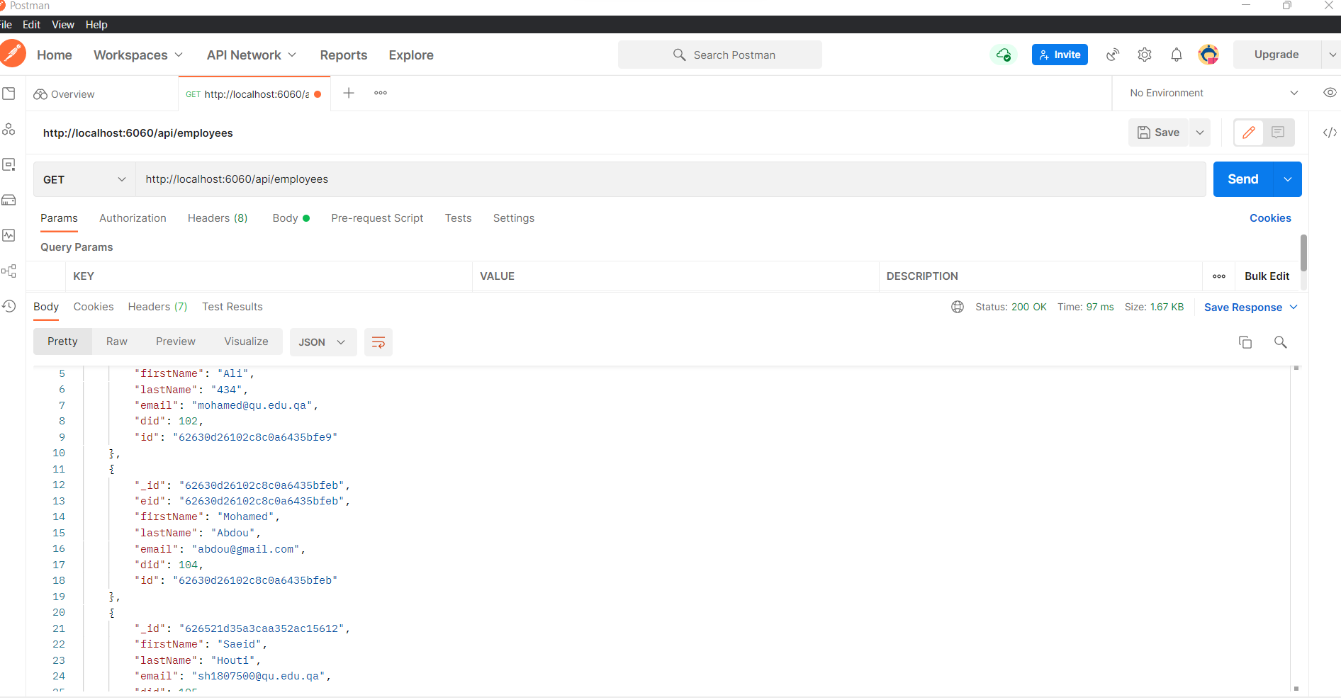

Deleting

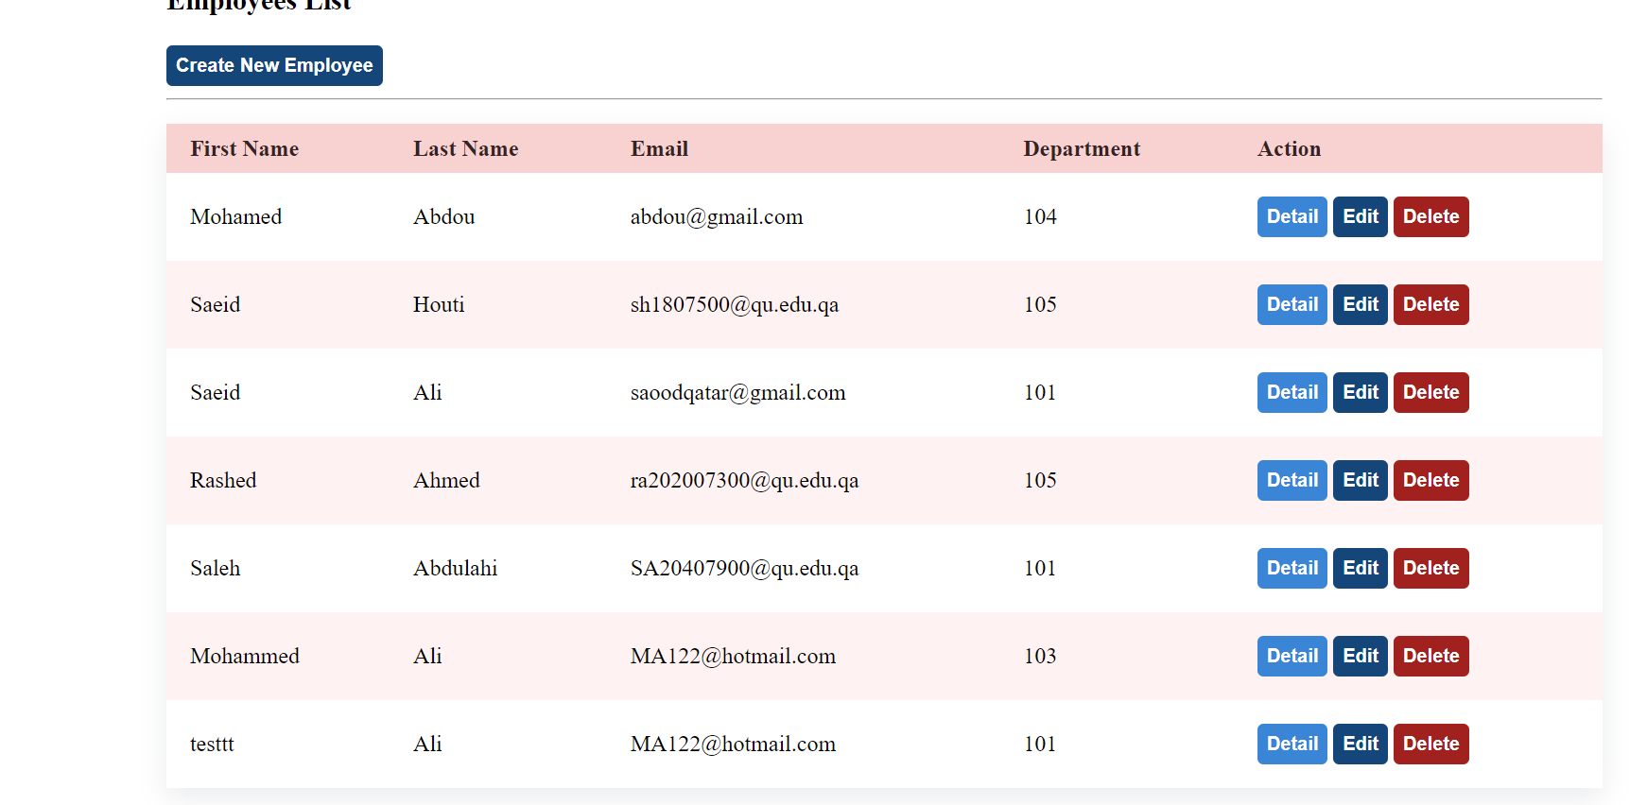

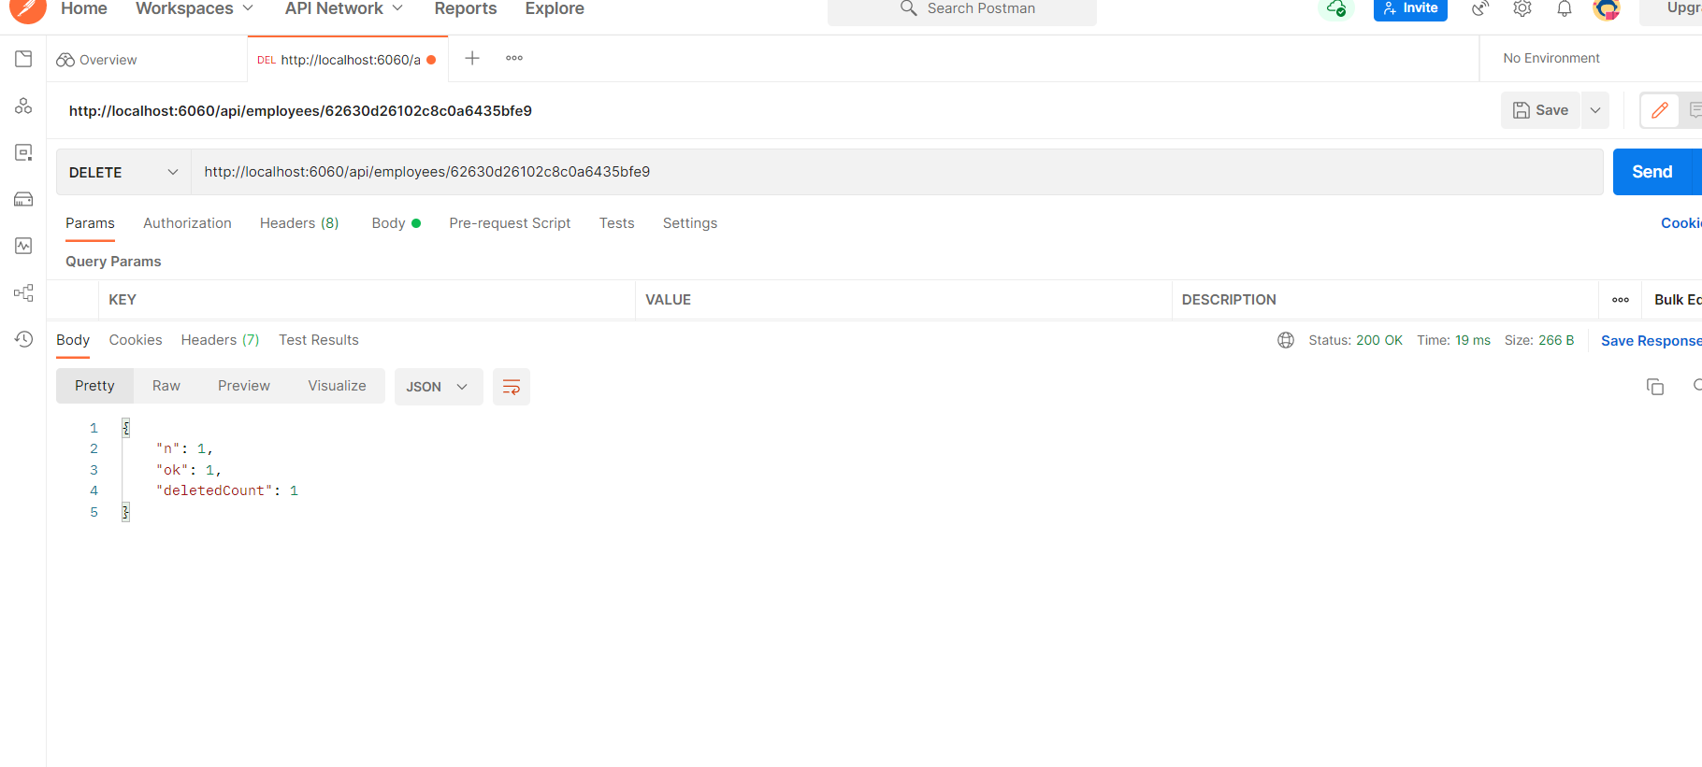Updating

